Hands-on Lab: Controlling Tone, Style, and Output
Scenario: AI Training Program Update
You are a trainer. Your AI training program is 80% completed, and you need to communicate the progress to different audiences using different tones, writing styles, and output formats.
Sample input data
Information | Details
Training program | Generative AI
Participants | 25 employees
Completion | 80%
Feedback rating | 4.5/5
Pending activity | Final assessment
Deadline | November 10

Sample prompt:
Act as a corporate training coordinator.
Write an update about the Generative AI training program.
Training completion: 80%
Participants: 25 employees
Feedback rating: 4.5/5

Write the update in two different tones:
1. Formal tone for senior management.
2. Informal tone for the training team.
Keep each version under 50 words.

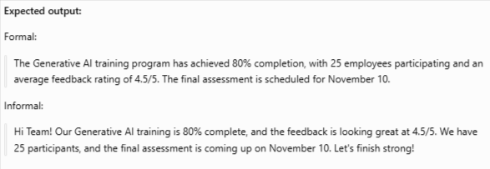

Practical Task 2: Control the Writing Style
Prompt:
Act as a corporate communication specialist.
Using the training information provided, create two versions:
1. Professional writing for a management email.
2. Conversational writing for a WhatsApp team update.

Include:
- Training completion
- Feedback rating
- Next activity
Use simple English.
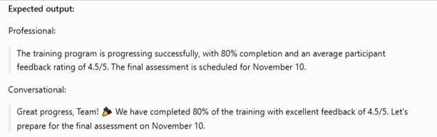

Practical Task 3: Control the Output Format
Prompt:
Act as a training reporting analyst.
Create a training progress summary using the following information:

Program: Generative AI
Participants: 25
Completion: 80%
Feedback: 4.5/5
Next activity: Final assessment
Deadline: November 10
Generate three outputs:

1. A table
2. Five bullet points
3. A JSON object
Use professional English.
Do not add information.


